**Director of Marketing Communications**

The United Soybean Board (USB) seeks a strategic leader to drive our marketing communications efforts for the soy, the second-largest crop in the United States. This role offers a unique opportunity to impact the lives of 500,000 soybean farmers while shaping the future of a growing team at USB and sustainable agriculture across the U.S.

**Responsibilities**:

* Develop innovative go-to-market strategies to drive demand for soy across the food, feed, fuel, and industrial sectors.
* Lead audience segmentation efforts and create targeted marketing approaches to maximize ROI.
* Collaborate with Reputation & Insights and Strategy teams to lead, create, and implement strategic plans with internal and external key stakeholder groups.
* Continuously refine marketing communications strategies, infrastructure, and processes.
* Manage internal and agency teams to achieve targeted marketing outcomes.
* Research and analyze market trends to identify new opportunities for U.S. soy promotion.
* Set strategic direction for all MarComm initiatives and align key stakeholder groups to shared goals.
* Monitor key metrics and continually optimize content, channels, and program investments.
* 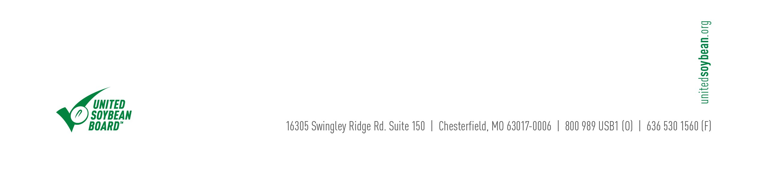Prepare and deliver reports on marketing communication programs and sustainability progress to leadership teams and committees.

**Required Qualifications & Competencies:**

* Bachelor's degree in marketing, communications, or a related field.
* 10+ years of professional experience in related role(s), with a background in the agriculture industry.
* Demonstrated expertise in strategic marketing, audience segmentation, and program execution.
* Strong knowledge of Agricultural Marketing Service (AMS) and U.S. Department of Agriculture (USDA) program guidelines.
* Excellent communication skills, with the ability to translate complex concepts into universally understandable content.
* Proficiency in MS Office Suite and familiarity with website platforms and content management systems.
* Previous experience working effectively with Qualified State Soybean Boards (QSSBs) is highly preferred.
* Ability to travel 25-50%.

**Compensation & Benefits:**

* Competitive salary based on qualifications and experience.
* Comprehensive benefits
* Opportunity for annual bonus

**About USB Careers**

Working at the United Soybean Board (USB) offers a unique opportunity to be part of a purpose-driven organization dedicated to advancing sustainable agriculture. Our team channels individual passion into meaningful collective action, contributing to innovative research and market development projects that enhance the competitiveness of U.S. Soy. With a focus on sustainability and a passion for supporting America's farmers, USB allows each role to have industry-wide impact in an environment of transparency, efficiency, and mutual respect. Together, we are shaping the future of agriculture for farmers, consumers, and the global food system.

**To apply, please submit your resume and cover letter to careers@unitedsoybean.org.** For more information about USB and our work, visi[t www.unitedsoybean.org.](http://www.unitedsoybean.org/)

*The United Soybean Board is an equal opportunity employer. We are committed to the principle of equal employment opportunity for all applicants and employees and to provide a work environment free of discrimination, retaliation, and harassment. All employment decisions at USB are made without regard to race; color; religion; national, social, or ethnic origin; sex (including pregnancy and/or pregnancy related conditions); age; physical, mental, or sensory disability; HIV status; sexual orientation; gender identity, and/or expression; marital, civil union, or domestic partnership status; past or present military service; family medical history or genetic information; family or parental status; or any other status protected by State, Local, or Federal laws in the locations where we operate. USB will not tolerate discrimination or harassment based on any of these characteristics and will not tolerate unlawful retaliation for participating in protected activities.*

*Applicants who require reasonable accommodation to participate in the application or interview process should contact Amber James (ajames@unitedsoybean.org) to request assistance.*